**Hands on 1**

**Create a Spring Web Project using Maven**

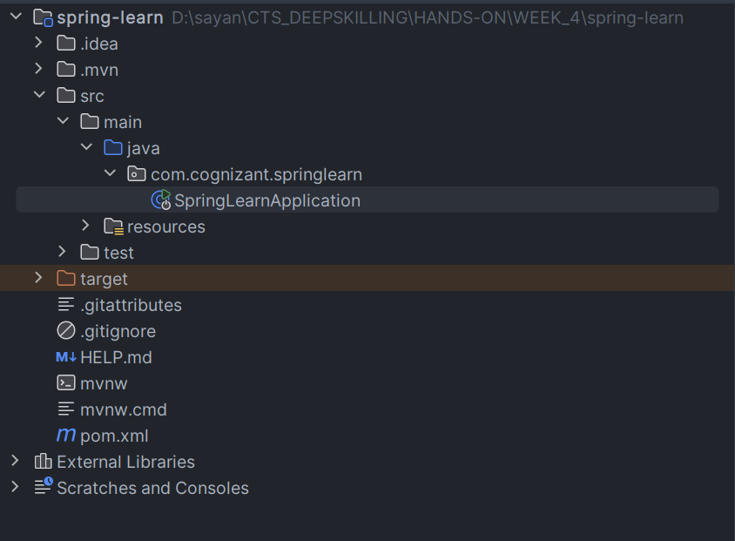Project Structure:

Main class:

*package* com.cognizant.springlearn;  
  
*import* org.slf4j.Logger;  
*import* org.slf4j.LoggerFactory;  
*import* org.springframework.boot.SpringApplication;  
*import* org.springframework.boot.autoconfigure.*SpringBootApplication*;  
  
*@SpringBootApplication  
public class* SpringLearnApplication {  
  
 *private static final* Logger LOGGER = LoggerFactory.getLogger(SpringLearnApplication.*class*);  
  
 *public static void* main(String[] args) {  
  
 SpringApplication.run(SpringLearnApplication.*class*, args);  
 LOGGER.info("Inside Main class");  
  
 }  
  
}

OUTPUT:

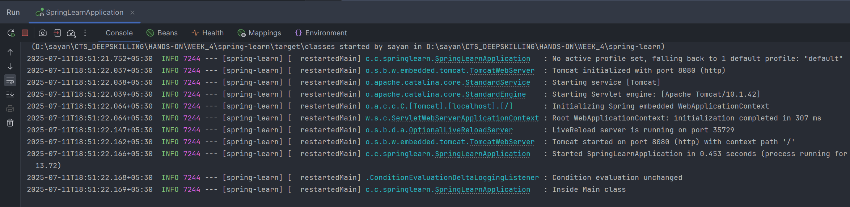

**Hands on 4**

**Spring Core – Load Country from Spring Configuration XML** 

Country class:

*package* com.cognizant.springlearn;  
  
*import* org.slf4j.LoggerFactory;  
  
*public class* Country {  
 *private* String code;  
 *private* String name;  
  
 *public* Country() {  
 LoggerFactory.getLogger(Country.*class*).debug("Inside Country Constructor.");  
 }  
  
 *public* String getCode() {  
 *return* code;  
 }  
  
 *public void* setCode(String code) {  
 *this*.code = code;  
 }  
  
 *public* String getName() {  
 *return* name;  
 }  
  
 *public void* setName(String name) {  
 *this*.name = name;  
 }  
  
 *@Override  
 public* String toString() {  
 *return* "Country{" +  
 "code='" + code + '\'' +  
 ", name='" + name + '\'' +  
 '}';  
 }  
}

Country.xml:

<?xml version="1.0" encoding="UTF-8"?>  
<beans xmlns="http://www.springframework.org/schema/beans"  
 xmlns:xsi="http://www.w3.org/2001/XMLSchema-instance"  
 xsi:schemaLocation="http://www.springframework.org/schema/beans http://www.springframework.org/schema/beans/spring-beans.xsd">  
  
  
 <bean class="com.cognizant.springlearn.Country" id="country">  
 <property name="code" value="IN"/>  
 <property name="name" value="India"/>  
 </bean>  
</beans>

Main class:

*package* com.cognizant.springlearn;  
  
*import* org.slf4j.Logger;  
*import* org.slf4j.LoggerFactory;  
*import* org.springframework.boot.SpringApplication;  
*import* org.springframework.boot.autoconfigure.*SpringBootApplication*;  
*import* org.springframework.context.ApplicationContext;  
*import* org.springframework.context.support.ClassPathXmlApplicationContext;  
  
*@SpringBootApplication  
public class* SpringLearnApplication {  
  
 *private static final* Logger LOGGER = LoggerFactory.getLogger(SpringLearnApplication.*class*);  
  
 *private static void* displayCountry(){  
 ApplicationContext context = *new* ClassPathXmlApplicationContext("country.xml");  
 Country country = context.getBean("country", Country.*class*);  
 LOGGER.info("Country : {}", country);  
 }  
  
 *public static void* main(String[] args) {  
  
 SpringApplication.run(SpringLearnApplication.*class*, args);  
 LOGGER.info("Inside Main class");  
  
 displayCountry();  
  
  
 }  
  
}

OUTPUT:

